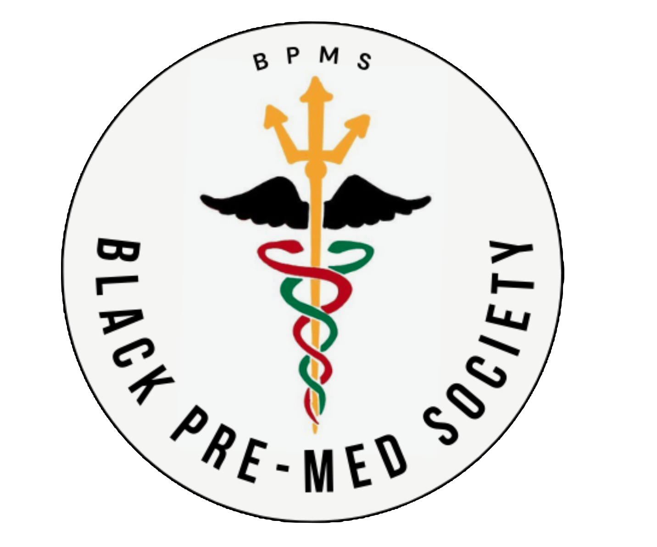

Background:  
 Among students interested in a STEM field at the start of their bachelor’s degree, black students have the highest rates of switching to a non-STEM field major (36 percent) according to the U.S. Department of Education (2003-2009). One of the most crucial aspects of this dropout rate for black pre-med students is the feeling of being isolated. As the Black Pre-Medical Society at UC San Diego, we focus on the inclusion and advancement of all pre-health students of the Black Diaspora through providing resources, community, and guidance.

Mission Statement:  
 The purpose of this organization is to bring together a community of unique students of, and allies to, the Black Diaspora interested in pre-health professions on campus. We aim to provide educational resources, leadership opportunities, and volunteer opportunities to students who have limited support for applying to pre-health schools. These students include, but are not limited to: black students, allies of the black community, first generation college students, students considering a health profession, students pursuing a major in departments other than biology and chemistry, students belonging to other demographics that are underserved in health professions, students who decided to be pre-health in their later years, and students returning to school after several years in the workforce and considering a health profession. However, all students interested in health professions are welcomed to join.

**Constitution for The Black Pre-Medical Society at UC San Diego:**

Article I. Name of Student Organization  
 a. The organization shall be called Black Pre-Medical Society at UC San Diego. Also referred to as the Black Pre-Med Society (abbreviated as BPMs).

Article II. Statement of Purpose  
 a. The purpose of this organization is to bring together a community of unique students of, and allies to, the Black Diaspora interested in pre-health professions on campus. We aim to provide educational resources, leadership opportunities, and volunteer opportunities to students who have limited support for applying to pre-health schools. These students include, but are not limited to: black students, allies of the black community, first generation college students, students considering a health profession, students pursuing a major in departments other than biology and chemistry, students belonging to other demographics that are underserved in health professions, students who decided to be pre-health in their later years, and students returning to school after several years in the workforce and considering a health profession. However, all students interested in health professions are welcomed to join.

b. The Black Pre-Med Society is a non-profit organization focused on proactively helping black students achieve their goal of acceptance into a health-related professional school, as well as providing opportunities to gain insight into their desired profession.

Article III. Nonprofit Statement  
 a. The Black Pre-Med Society at UC San Diego is a non-profit student organization.

Article IV. Membership Requirements  
 a. Active membership of a member is determined by:  
 i. Attendance: members must participate in at least two meetings per quarter.  
 ii. Conduct: All members must abide by the conduct established by the Center for Student Involvement.  
 b. While the focus of The BPMs at UC San Diego is geared toward the advancement of students a part of the Black Diaspora at the university, all UC San Diego students interested in health professions are welcome.

Article V. Frequency of Organization Meetings  
 a. The time and date of organizational meetings for The Black Pre-Med Society is to be decided by popular vote among the principal members. There will be a minimum of three meetings per academic quarter.

Article VI. Qualifications for Holding Oce and Methods of Selecting and Replacing Officers  
 a. Only registered UC San Diego students may hold office in the organization. Only registered UC San Diego students may vote in elections for the selection of the organization’s office. b. Any person wishing to hold office in The BPMs must already be an active member. The member board, consisting of the principal members, will determine eligibility for officer positions. Appointment of officer positions will be determined by a majority vote by the current officer board.

c. A prospective officer shall be defined as a member who has attended a minimum of three meetings in the quarter or with attendance equal or greater than 70% attendance at organization events per quarter.  
 d. Prospective officers shall submit an application as established by the organization’s officers and be interviewed by the officers during Winter quarter.

e. The annual officer interview will occur in Fall quarter and incumbent officers will shadow the officer board during Winter quarter.  
 f. Subcommittees will be established upon majority vote of board members.  
 g. In the event of failure to perform officer and chair duties, a review committee will be formed to review officer performance and decide upon appropriate action(s) by majority vote.

Article VII. Risk Management  
 a. The Black Pre-Medical Society at UC San Diego is a registered student organization at the University of California, San Diego, but not part of the University itself.  
 b. The Black Pre-Medical Society at UC San Diego understands that the University does not assume legal liability for the actions of the organization.

Article VII. Section 1.  
 In Case of Interaction with Minors and/or the Elderly  
 a. The Black Pre-Medical Society at UC San Diego is aware that all registered student organizations that serve minors or the elderly have access to training on child and elder abuse prevention for its members via the Center for Student Involvement, online or in person (in person by request only). The Black Pre-Med Society will develop plan(s) for activities and events where members will be interacting with minors or the elderly such that members will receive education and/or training on Child Abuse Neglect Reporting Act (CANRA), common sense measures to both avoid child or elder abuse allegations (i.e. avoiding one-on-one situations; working with minors in plain view of others; limiting calls/texts/social media posts or other communications with minors), and how to properly report potential harm or neglect to minors or the elderly with whom they are working.

Article VII. Section 2.  
 In Case of the Provision of Medical Assistance  
 a. In the event that The Black Pre-Medical Society at UC San Diego provides medical assistance to a community, all volunteers will work under the direction of licensed medical professionals (doctors, nurses, counselors, etc.). The University does not recommend that students provide medical assistance.

Article VII. Section 3.  
 In Case of International Travel  
 a. The Black Pre-Medical Society at UC San Diego recognizes that the University generally recommends against all international travel by Student Organizations due to the myriad of risks travelers face in foreign countries. Student organizations are discouraged from traveling to foreign countries due to the wide variety of risks involved with foreign travel, and the extensive planning efforts required by the Student Organization’s Members to manage those risks. Security risks and health care services vary widely from one country to another, so thorough research on those topics is especially important. International travelers are advised to research US State Department Travel Advisories and the CDC Travel Health site and abide by all recommended alerts and warnings, and procure travel insurance with medical coverage that covers their chosen destination because most USA Health Plans are not valid in foreign countries.

Article VII. Section 4.  
 In Case of Handling of Hazardous Chemicals, Material, Equipment, and/or Machinery  
 a. The Black Pre-Medical Society at UC San Diego recognizes that all student organization activities must be conducted safely, in accordance with all applicable federal, state and local laws. Additionally, [The Black Pre-Med Society] will abide by UC San Diego requirements for students in labs, including policies for minors in UC laboratories, and ensure members receive safety training regarding the use of chemicals and/or machinery before entering the lab. Members must follow any best practices and lab safety protocols for the use of such chemicals, research equipment or machinery, including the appropriate use of Personal Protective Equipment, and should work under close supervision of those trained in the handling of chemicals/use of research equipment or machinery.

Article VIII. Community Advisor  
 a. The Community Advisor of The Black Pre-Medical Society at UC San Diego will be selected by principal members. The length of Community Advisors’ terms will be determined at the discretion of the principal members of The Black Pre-Medical Society at UC San Diego. The Community Advisor must be allocated with a health profession or health professions advising through Health Beat.  
 b. The Community Advisor’s role includes: i. advising board members in administrative tasks (i.e. budgeting, procedures, etc.); ii. meet regularly with board members to keep current on projects and events the organization is planning; iii. make appropriate referrals to campus and community resources; iv. interpret and ensure organization members adhere to policies; v. meet with treasurer/finance director as needed to assure accurate record-keeping and budgeting; vi. Community Advisors are encouraged to attend all BPMs at UC San Diego meetings and must meet with board member(s) at least once per quarter to be updated on upcoming events and future plans.

Article IX. Treasurer: Financial Management  
 a. The treasurer and/or the fundraising chair will be charged with: i. Financing BPMs at UC San Diego activities by applying for A.S. funding; ii. Receiving financial education through A.S. Funding Guide Seminar; iii. Facilitating fundraising activities; iv. Securing reimbursement for club specific event related out-of-pocket expenses of members. b. In the event that there is no treasurer elected or available, the officers will discuss and delegate financial management tasks amongst the officer board by a majority vote.

Article X. Aliation with Other Groups  
 a. The BPMs at UC San Diego is affiliated with Health Beat: the pulse of health professions at UC San Diego.

b. This aliation designates BPMs as a Health Beat-aliated organization and receives annual updates and information regarding the pre-health professional school application process and advice from the professional advisors of Health Beat.

c. This aliation also provides BPMs officers with an invitation to the quarterly health professions organization town hall hosted by Health Beat.

d. BPMs officers will work closely with HealthBeat to provide educational and informational events for the benefit of BPMs members, as well as additional resources regarding individual member advising for preparation to apply for health profession schools.